Class Design
- Initial Design Classes

- Define Relationships between classes
- Class Design
  - Class “DetailedBikeView”:
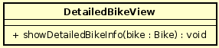
Attribute
None
Operation
# | Name | Return type | Description (purpose)
1 | showDetailedBikeInfo | Void | Display the detailed bike information view
Parameter
- bike – the bike selected
Exception
None
Method
None
State
None
  - Class “RentedBikeView”
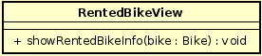
Attribute
None
Operation
# | Name | Return type | Description (purpose)
1 | showRentedBikeInfo | Void | Display the rented bike information view
Parameter
- bike – the bike selected
Exception
None
Method
None
State
None
  - Class “BikeController”
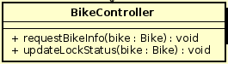
Attribute
None
Operation

# | Name | Return type | Description (purpose)
1 | requestBikeInfo | Void | Request all related information for selected bike from database
2 | updateLockStatus | Void | Change rented bike’s lock status

Parameter
- bike – the bike selected
Exception
None
Method
None
State
None
  - Class “Bike”
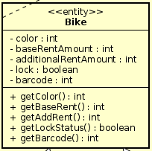
Attribute

# | Name | Data type | Default value | Description
1 | color | int | NULL | Color of the bike
2 | baseRentAmount | int | NULL | Base amount of rent for the bike
3 | additionalRentAmount | int | NULL | Additional amount of rent for the bike
4 | lock | boolean | NULL | Lock status for rented bike
5 | barcode | int | NULL | Barcode of the bike

Operation

# | Name | Return type | Description (purpose)
1 | getColor | int | Request selected bike’s color
2 | getBaseRent | int | Request selected bike’s base rent amount
3 | getAddRent | int | Request selected bike’s additional rent amount
4 | getLockStatus | boolean | Request selected bike’s lock status
5 | getBarcode | int | Request selected bike’s barcode

Parameter
- bike – the bike selected
Exception
None
Method
None
State
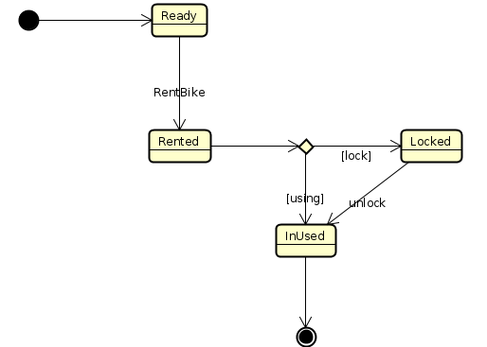

- Class Diagram

